

**Diploma in ICT & Computing**

**Unit 03 - Introduction to Visual Programming**

**Practical Examination Paper**

***Time :3 Hours***

***Instructions to Invigilators,***

***No reference material of any kind be taken in to the examination hall by the students*.**

**Assumptions**

* An employee Works 8 hours per day.
* **No Pay Rate (per day)** is calculate by **Basic Salary/30 days**.
* **Rate Per Hour** is calculate by **Basic Salary/(30 days × 8 hrs)**
* **Total Additions= Additional Hours * Rate per hour.**
* **Total Deduction= No pay days * No Pay Rate (Per Day)**
* **Net Salary= (Basic Salary + Total additions) -Total Deductions.**

**Task 1**

Create the following interface using VB.NET

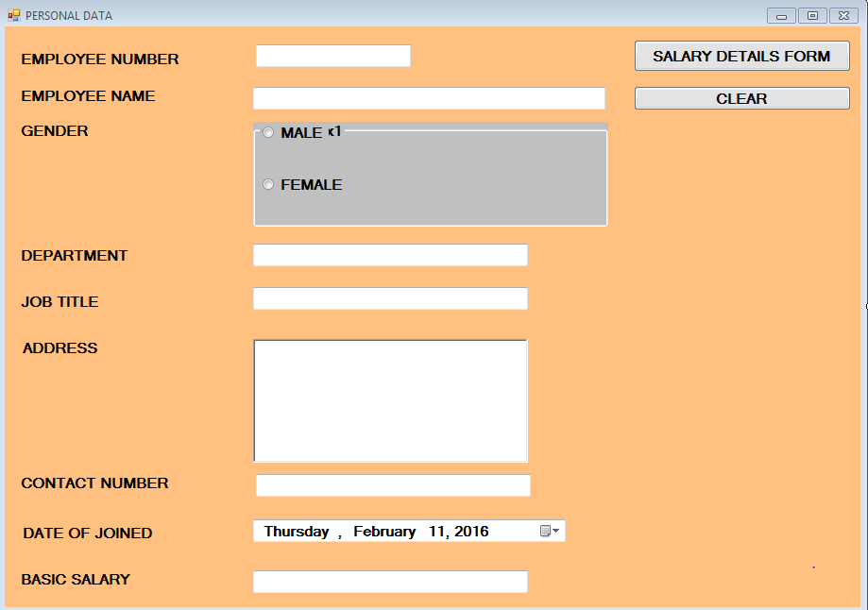**Form 1: Personal Data**

**Form 2: Salary Calculation**

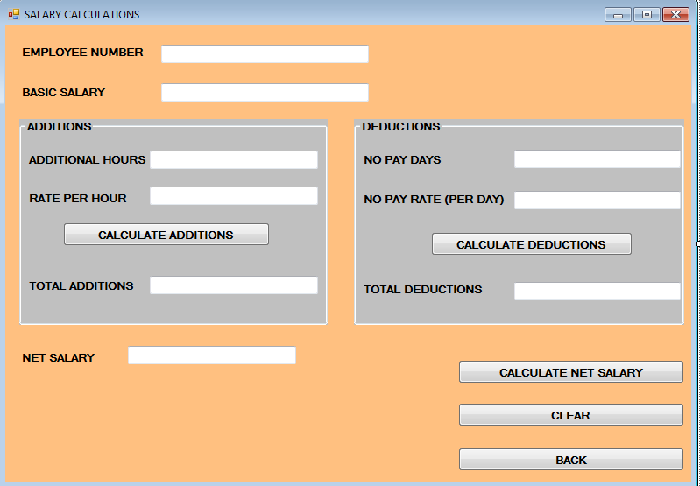

**Task 2**

Perform the following actions with appropriate event procedures

**Form 1**

* When the **form 1** is appears to the screen, do not allow the user to accept the “**Salary Details Form”** button, then after that entering the data to the available TextBoxes & then allow the user to access “**Salary Details Form**” button again.
* By clicking the **“Salary Details Form**” button hide the current form (form 1) and display the Second form (form 2).
* By clicking the “**clear”** button refresh the form for a new process.

**Form 2:**

* When the **form 2** is load in to the Screen display the “**Employee Number”** and **“Basic Salary”** from the form 1.
* After entering the **“Additional Hours”** calculate the “**Rate per Hour**” According to the given formula.
* By clicking the “Calculate Addition” button calculate the **“Total Additions”**
* After entering the “**No Pay Days”** calculate the “**No Pay Rate (per day)”** according to the given formula.
* Then calculate the **“Net Salary**” according to the given formula.
* By clicking the “**clear**” button refresh the form 2.
* By clicking the “**Back”** button ask that “do you want to get the personal data form?” .and if the response is “yes” display the first form otherwise Stop the programme.

***Note:***

* You need to provide a correct naming method when designing the form designers (use meaning full names for controls).
* Use additional messages as required to direct the user and handle errors and additional controlling methods to increase the user friendliness.